**Group 5: HealthScope**

**Motivation & Decision**

We are excited to release our application named **HealthScope** which is android based app developed using ionic framework. HealthScope is mainly based on the face that nowadays more and more *sub-health* occurs amongst young people and college students. Overweight, diabetes and hypertension, such senior health issues have gradually moved to the young people. It is the age we are living that contains a lot of fast-food and high-sweet food around us and adversely affected our everyday life. We discovered that the similarities between these kinds of disease are:

1. These health issues are all reversible issues by changing life style.
2. These health issues have no obvious symptoms when it begins to occur, but it may cause severe, life-threatening, or fatal health problems if people take care of them too late.

Accordingly, the best way to deal with such kinds of sub-health issues is to monitor some typical health parameters in our daily life, in order for the early discovery of our potential health issues. Therefore, a nice solution to deal with this problem was to design a useful tiny application that can analyze the inputs of some physical parameters. What is more, based on the analytical result the program has given, it also provided some basic suggestions related to “how to improve yourself”, e.g. what kind of diet is recommended and how many calories the best number for a daily is eating.

Compared with the current existing application we can find related to weight control or blood pressure control, we introduced something new to our program, that is, the **graphical analysis**. This is a picture-reading age we are living. A graph may worth a thousand words. Consequently, our program makes mathematical/statistical curves that represent the changes of certain physical parameters of the user in the last week or month. Also, it can analyze the curve and detect whether or not you did a good job for your health in that time period.

**How the system works**

The application we have designed is pretty easy to use. We are giving the android executable file or the ‘apk’ file which is needed to install the app on your android mobile/tablets. Once you are done with that you will have the following features in our app:

1. Registration

|  |  |
| --- | --- |
|  | This is the registration page of our app. The users need to register first with us and then they can use the app. All they need to do is to input the username, DOB, email Id , password and their profile picture (this is optional) |

1. Sign-In

|  |  |
| --- | --- |
|  | This is the login page of our app. The registered user needs to enter their username and the password to login to the app. Make sure you are connected to internet otherwise you’ll be prompted to do so. |

1. Change password

|  |  |
| --- | --- |
|  | This is app screen to change the password. Users need to enter their current password and the new password which they want to set. |

1. Hypertension
   1. Checkup and display

|  |  |
| --- | --- |
|  | This is the hypertension check-up screen. User needs to input two diagnosis values namely DBP and SBP. Once user does that they will be returned result stating their condition based on the values they entered. The values that can be returned are as :   * Normal * Pre-hypertension * Hypertension Stage 1 * Hypertension Stage 2 * Hypertension Stage 3 |

* 1. Home Remedies

|  |  |
| --- | --- |
|  | This is app screen to suggest what should be preferred when they are detected with hypertension |

* 1. History

|  |  |
| --- | --- |
|  | This is the app screen to display their previous diagnosis and that they can see their progress. |

* 1. Ask the experts

|  |  |
| --- | --- |
|  | We have certain videos in the app that talks more about hypertension. Users can watch and learn more information about hypertension. |

1. Diabetes
   1. Checkup and lasted three detections

|  |  |
| --- | --- |
|  | This is the diabetes check-up screen. User needs to input two diagnosis values namely fasting glucose and 2-hour glucose. Once user does that they will be returned result stating their condition based on the values they entered. The values that can be returned are as:   * Normal * Impaired fasting glycaemia glucose * Impaired glucose tolerance * Diabetes mellitus   At the same time, the lasted three detection records are shown to user. |

* 1. Diet suggestion

|  |  |
| --- | --- |
|  | This is the diabetes suggestion screen. According to American diabetes association, diabetes patients should control their diet. “Create your own plate” is suggested by them. A mean can contain 25% protein, 25% Grains And Starchy Food and 50% Non-Starchy Vegetable. The user can select the food and created the plate. A tip of the food is also provided. |

* 1. Diabetes detection history

|  |  |
| --- | --- |
|  | This is the diabetes history screen. User can select the time period he/she wants to know. Then the two sugar levels and detection results are shown in graph. |

1. Overweight
   1. Checkup

|  |  |
| --- | --- |
|  | This is the overweight check-up screen. The user provides the body measurement information: weight measurement in Lbs; height measurements in feet and inches; gender type. Then the user clicks "CHECK UP" to detect overweight. |

* 1. Display the detection result and get suggestion

|  |  |
| --- | --- |
|  | The system will collect input measurements and return one of possible diagnosis   * Underweight * Normal * Overweight * Obese   Also, the following values will show:   * BMI value * Daily calories consumption according to diagnosis   If diagnosis is Underweight, weight gaining calories consumption will be returned; If diagnosis is Normal, weight maintaining calories consumption will be returned; If diagnosis is Overweight, weight losing calories consumption will be returned; If diagnosis is Obese, weight losing calories consumption will be returned. Recommended weight range to maintain to be healthy according to given height and gender.   * Recommended next checkup date |

* 1. History

|  |  |
| --- | --- |
|  | Weight history displays in two modes   * The chart to show weight changing trend * The timeline to show detailed information of each checkup point   Little arrows are use to depict weight gaining or weight losing (pointing up mean gaining and pointing down means losing). The arrow's color to inform user negative or positive affect of the weight changing (green means positive, red means negative). Net weight displays the weight value user provided for that checkup point. The hint below Net weight shows exact amount of weight lose or gain relative to the previous checkup point, inferred and displayed so user do need to calculate in their head. The top right corner shows the date of the checkup point |

**Error recognition and handling**

1. No Internet connection

If the user has no Internet connection, there is an alert pop up and ask user to check it.

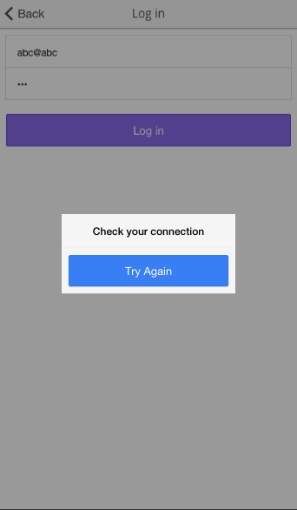

1. Uncorrected credentials

If user inputs wrong login credentials, the following alert will pop up. In that case, the user should retype the correct credentials in order to login.

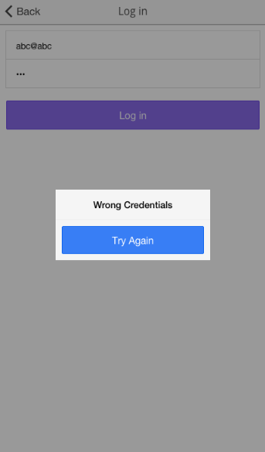

**Known Issues**

1. Multiple detections in the same day will be recorded in the system. Our app doesn’t update the results detected in the same day.
2. The user profile image is not saved and user even it’s taken.
3. The user password is raw text, we don’t encrypt the user password.